Министерство науки и высшего образования Российской Федерации
Федеральное государственное бюджетное образовательное учреждение
высшего образования
«Рязанский государственный радиотехнический университет имени В. Ф. Уткина»
Кафедра «Вычислительная и прикладная математика»

Отчет по лабораторной работе №2
по дисциплине «Объектно-ориентированное программирование»
на тему «Простые классы»

Выполнил: студент гр.1413
Аверкин М.Е.
Проверил: профессор
доц. Антипов О.В.

Цель работы: переделать 1-ую лабораторную работу, используя классы. Понять механизм работы с классами, модификаторами доступа. Провести юнит-тесты.
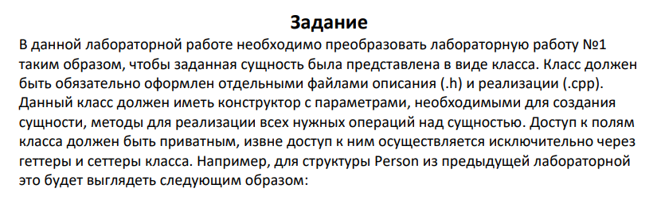
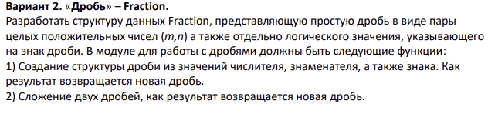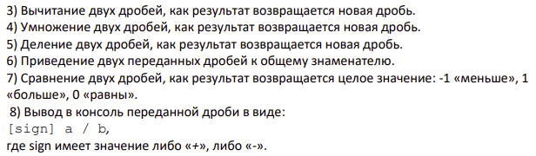

Анализ задания:
Входные данные: boolean значение, определяющее, дробь положительная или отрицательная; знаменатель дроби; числитель дроби.
В зависимости от задания: Дополнительная дробь с boolean значением, определяющим, дробь положительная или отрицательная; знаменатель дроби; числитель дроби.

Промежуточные данные: переменная choice, выступающая в виде параметра результата сравнения двух дробей.
Выходные данные: дроби, над которыми проведены запрашиваемые операции.
Математические методы: приведение дробей к общему знаменателю, сложение дробей, умножение дробей, деление дробей, вычитание дробей, сравнение двух дробей.
Описание структуры:
Структура состоит из двух целочисленных переменных, отвечающих за знаменатель и числитель дроби, а так же из Boolean переменной isNegative, определяющей, является ли дробь отрицательной или положительный ( True – отрицательная, а False – положительная).
Листинг программы:

Main.cpp

#include <iostream>
#include "Fraction.h"
#include "UnitTest.h"

int main(int argc, char** argv)
{
cout << "This program tests the 1st lab" << endl;
(FractionTest()).run();

return 0;
}

Fraction.cpp

#include "Fraction.h"
#include <stdbool.h>
#include <iostream>

Fraction Fraction::Commondenominator(Fraction otherFraction){
Fraction resultFraction;
int CommonD = this->denominator * otherFraction.denominator;
resultFraction.numerator = this->numerator*otherFraction.denominator;
resultFraction.denominator = CommonD;
resultFraction.isNegative = this->isNegative;

return resultFraction;
}

Fraction Fraction::SumFractions(Fraction otherFraction){
Fraction resultFraction;

int IntSign1, IntSign2;

IntSign1 = this->Translation();

IntSign2 = otherFraction.Translation();

resultFraction.numerator = IntSign1*this->numerator + IntSign2*otherFraction.numerator;
resultFraction.denominator = this->denominator;

if (resultFraction.numerator<0){
resultFraction.isNegative = true;
resultFraction.numerator = resultFraction.numerator*(-1);
}
else{
resultFraction.isNegative = false;
}

return resultFraction;
}

Fraction Fraction::SubFractions(Fraction otherFraction){
Fraction resultFraction;

int IntSign1, IntSign2;

IntSign1 = this->Translation();

IntSign2 = otherFraction.Translation();

resultFraction.numerator = IntSign1*this->numerator - IntSign2*otherFraction.numerator;
resultFraction.denominator = this->denominator;

if (resultFraction.numerator<0){
resultFraction.isNegative = true;
resultFraction.numerator = resultFraction.numerator*(-1);
}
else{
resultFraction.isNegative = false;
}

return resultFraction;
}

Fraction Fraction::MultFractions(Fraction otherFraction){
Fraction resultFraction;
int IntSign1, IntSign2;

IntSign1 = this->Translation();

IntSign2 = otherFraction.Translation();

resultFraction.numerator = this->numerator*otherFraction.numerator;
resultFraction.denominator = this->denominator*otherFraction.denominator;
resultFraction.isNegative = IntSign1*IntSign2 < 0 ? true: false;

return resultFraction;
}

Fraction Fraction::DivFractions(Fraction otherFraction){
Fraction resultFraction;
int IntSign1, IntSign2;

IntSign1 = this->Translation();

IntSign2 = otherFraction.Translation();

resultFraction.numerator = this->numerator*otherFraction.denominator;
resultFraction.denominator = this->denominator*otherFraction.numerator;
resultFraction.isNegative = IntSign1*IntSign2 < 0 ? true: false;

return resultFraction;
}

int Fraction::CompFractions(Fraction otherFraction){
int Comparison;
int IntSign1, IntSign2;

IntSign1 = this->Translation();

IntSign2 = otherFraction.Translation();

if (IntSign1*this->numerator > IntSign2*otherFraction.numerator){
Comparison = 1;
}
else if (IntSign1*this->numerator < IntSign2*otherFraction.numerator){
Comparison = -1;
}
else
Comparison = 0;

return Comparison;
}

Fraction.h
#pragma once
#include <stdbool.h>
#include <iostream>

using namespace std;

class Fraction
{
private:
int numerator;
int denominator;
bool isNegative;
public:
int Translation (){
int IntSign;
IntSign = this->isNegative ? -1 : 1;
return IntSign;
}

Fraction(int numerator,int denominator, bool isNegative){
this->numerator = numerator;
this->denominator = denominator;
this->isNegative = isNegative;
}

Fraction() {
}

int Comparison(Fraction otherFraction){
return (this->numerator == otherFraction.numerator) == (this->denominator == otherFraction.denominator) == (this->isNegative == otherFraction.isNegative);
}

void PrintFraction(){
this->isNegative ? cout << '-': cout << '+';
cout << '(' << this->numerator << '/' << this->denominator << ')' << endl;
}

Fraction Commondenominator(Fraction otherFraction);
Fraction SumFractions(Fraction otherFraction);
Fraction SubFractions(Fraction otherFraction);
Fraction MultFractions(Fraction otherFraction);
Fraction DivFractions(Fraction otherFraction);
int CompFractions(Fraction otherFraction);
};

UnitTest.cpp

#include "UnitTest.h"

void FractionTest::run()
{
startTest();

updateTestResult(CommondenominatorTest1());
updateTestResult(CommondenominatorTest2());
updateTestResult(SumFractionsTest1());
updateTestResult(SumFractionsTest2());
updateTestResult(SubFractionsTest1());
updateTestResult(SubFractionsTest2());
updateTestResult(DivFractionsTest());
updateTestResult(MultFractionsTest1());
updateTestResult(MultFractionsTest2());
updateTestResult(CompFractionsTest());

printTestResults();
}

void FractionTest::printTestResults()
{
cout << "Test results passed: " << testPassed << " of " << testTotal << endl;
}

void FractionTest::updateTestResult(bool passed)
{
if(passed)
++testPassed, cout << "Success!" << endl;
else
cout << "Failure!" << endl;
}

bool FractionTest::assertValueVal(int actual, int expected)
{
cout << "Expected Result: " << expected << endl;
cout << "Actual result: " << actual << endl;
return actual == expected;
}

bool FractionTest::assertValueFrac(Fraction actual, Fraction expected)
{
cout << "Expected Result: ";
expected.PrintFraction();
cout << "Actual result: ";
actual.PrintFraction();
return actual.Comparison(expected);
}

bool FractionTest::CommondenominatorTest1(){
cout << "(1)Testing the Commondenominator: fractions must be reduced to a common denominator" << endl;

int arrangeNumerator = 28;
int arrangeDenominator = 12;
bool arrangeIsNegative = true;

int referenceNumerator1 = 7;
int referenceDenominator1 = 3;
bool referenceIsNegative1 = true;
Fraction Fraction1 = Fraction(referenceNumerator1,referenceDenominator1,referenceIsNegative1);

int referenceNumerator2 = 3;
int referenceDenominator2 = 4;
bool referenceIsNegative2 = false;
Fraction Fraction2 = Fraction(referenceNumerator2,referenceDenominator2,referenceIsNegative2);

//must be
Fraction TestFraction = Fraction(arrangeNumerator,arrangeDenominator,arrangeIsNegative);

//do
Fraction ComFraction1 = Fraction1.Commondenominator(Fraction2);
Fraction ComFraction2 = Fraction2.Commondenominator(Fraction1);

//result
return assertValueFrac(TestFraction,ComFraction1);
}

bool FractionTest::CommondenominatorTest2(){
cout << "(2)Testing the Commondenominator: fractions must be reduced to a common denominator" << endl;

int arrangeNumerator = 9;
int arrangeDenominator = 12;
bool arrangeIsNegative = false;

int referenceNumerator1 = 7;
int referenceDenominator1 = 3;
bool referenceIsNegative1 = true;
Fraction Fraction1 = Fraction(referenceNumerator1,referenceDenominator1,referenceIsNegative1);

int referenceNumerator2 = 3;
int referenceDenominator2 = 4;
bool referenceIsNegative2 = false;
Fraction Fraction2 = Fraction(referenceNumerator2,referenceDenominator2,referenceIsNegative2);

//must be
Fraction TestFraction = Fraction(arrangeNumerator,arrangeDenominator,arrangeIsNegative);

//do
Fraction ComFraction1 = Fraction1.Commondenominator(Fraction2);
Fraction ComFraction2 = Fraction2.Commondenominator(Fraction1);

//result
return assertValueFrac(TestFraction,ComFraction2);
}

bool FractionTest::SumFractionsTest1(){
cout << "(1) Sum Check: Calculations must be correct." << endl;

int arrangeNumerator = 19;
int arrangeDenominator = 12;
bool arrangeIsNegative = true;

int referenceNumerator1 = 7;
int referenceDenominator1 = 3;
bool referenceIsNegative1 = true;
Fraction Fraction1 = Fraction(referenceNumerator1,referenceDenominator1,referenceIsNegative1);

int referenceNumerator2 = 3;
int referenceDenominator2 = 4;
bool referenceIsNegative2 = false;
Fraction Fraction2 = Fraction(referenceNumerator2,referenceDenominator2,referenceIsNegative2);

Fraction ComFraction1 = Fraction1.Commondenominator(Fraction2);
Fraction ComFraction2 = Fraction2.Commondenominator(Fraction1);

//must be
Fraction TestFraction = Fraction(arrangeNumerator,arrangeDenominator,arrangeIsNegative);

//do
Fraction resultFraction = ComFraction1.SumFractions(ComFraction2);

//result
return assertValueFrac(TestFraction,resultFraction);
}

bool FractionTest::SumFractionsTest2(){
cout << "(2) Sum Check: Calculations must be correct." << endl;

int arrangeNumerator = 37;
int arrangeDenominator = 12;
bool arrangeIsNegative = true;

int referenceNumerator1 = 7;
int referenceDenominator1 = 3;
bool referenceIsNegative1 = true;
Fraction Fraction1 = Fraction(referenceNumerator1,referenceDenominator1,referenceIsNegative1);

int referenceNumerator2 = 3;
int referenceDenominator2 = 4;
bool referenceIsNegative2 = true;
Fraction Fraction2 = Fraction(referenceNumerator2,referenceDenominator2,referenceIsNegative2);

Fraction ComFraction1 = Fraction1.Commondenominator(Fraction2);
Fraction ComFraction2 = Fraction2.Commondenominator(Fraction1);

//must be
Fraction TestFraction = Fraction(arrangeNumerator,arrangeDenominator,arrangeIsNegative);

//do
Fraction resultFraction = ComFraction1.SumFractions(ComFraction2);

//result
return assertValueFrac(TestFraction,resultFraction);
}

bool FractionTest::SubFractionsTest1(){
cout << "(1) Subtraction check: Calculations must be correct." << endl;

int arrangeNumerator = 19;
int arrangeDenominator = 12;
bool arrangeIsNegative = true;

int referenceNumerator1 = 7;
int referenceDenominator1 = 3;
bool referenceIsNegative1 = true;
Fraction Fraction1 = Fraction(referenceNumerator1,referenceDenominator1,referenceIsNegative1);

int referenceNumerator2 = 3;
int referenceDenominator2 = 4;
bool referenceIsNegative2 = true;
Fraction Fraction2 = Fraction(referenceNumerator2,referenceDenominator2,referenceIsNegative2);

Fraction ComFraction1 = Fraction1.Commondenominator(Fraction2);
Fraction ComFraction2 = Fraction2.Commondenominator(Fraction1);

//must be
Fraction TestFraction = Fraction(arrangeNumerator,arrangeDenominator,arrangeIsNegative);

//do
Fraction resultFraction = ComFraction1.SubFractions(ComFraction2);

//result
return assertValueFrac(TestFraction,resultFraction);
}

bool FractionTest::SubFractionsTest2(){
cout << "(2) Subtraction check: Calculations must be correct." << endl;

int arrangeNumerator = 37;
int arrangeDenominator = 12;
bool arrangeIsNegative = true;

int referenceNumerator1 = 7;
int referenceDenominator1 = 3;
bool referenceIsNegative1 = true;
Fraction Fraction1 = Fraction(referenceNumerator1,referenceDenominator1,referenceIsNegative1);

int referenceNumerator2 = 3;
int referenceDenominator2 = 4;
bool referenceIsNegative2 = false;
Fraction Fraction2 = Fraction(referenceNumerator2,referenceDenominator2,referenceIsNegative2);

Fraction ComFraction1 = Fraction1.Commondenominator(Fraction2);
Fraction ComFraction2 = Fraction2.Commondenominator(Fraction1);

//must be
Fraction TestFraction = Fraction(arrangeNumerator,arrangeDenominator,arrangeIsNegative);

//do
Fraction resultFraction = ComFraction1.SubFractions(ComFraction2);

//result
return assertValueFrac(TestFraction,resultFraction);
}

bool FractionTest::MultFractionsTest1(){
cout << "(1) Multiplication check: Calculations must be correct." << endl;

int arrangeNumerator = 21;
int arrangeDenominator = 12;
bool arrangeIsNegative = true;

int referenceNumerator1 = 7;
int referenceDenominator1 = 3;
bool referenceIsNegative1 = true;
Fraction Fraction1 = Fraction(referenceNumerator1,referenceDenominator1,referenceIsNegative1);

int referenceNumerator2 = 3;
int referenceDenominator2 = 4;
bool referenceIsNegative2 = false;
Fraction Fraction2 = Fraction(referenceNumerator2,referenceDenominator2,referenceIsNegative2);

//must be
Fraction TestFraction = Fraction(arrangeNumerator,arrangeDenominator,arrangeIsNegative);

//do
Fraction resultFraction = Fraction1.MultFractions(Fraction2);

//result
return assertValueFrac(TestFraction,resultFraction);
}

bool FractionTest::MultFractionsTest2(){
cout << "(2) Multiplication check: Calculations must be correct." << endl;

int arrangeNumerator = 21;
int arrangeDenominator = 12;
bool arrangeIsNegative = false;

int referenceNumerator1 = 7;
int referenceDenominator1 = 3;
bool referenceIsNegative1 = true;
Fraction Fraction1 = Fraction(referenceNumerator1,referenceDenominator1,referenceIsNegative1);

int referenceNumerator2 = 3;
int referenceDenominator2 = 4;
bool referenceIsNegative2 = true;
Fraction Fraction2 = Fraction(referenceNumerator2,referenceDenominator2,referenceIsNegative2);

//must be
Fraction TestFraction = Fraction(arrangeNumerator,arrangeDenominator,arrangeIsNegative);

//do
Fraction resultFraction = Fraction1.MultFractions(Fraction2);

//result
return assertValueFrac(TestFraction,resultFraction);
}

bool FractionTest::DivFractionsTest(){
cout << "(1) Division check: Calculations must be correct." << endl;

int arrangeNumerator = 9;
int arrangeDenominator = 28;
bool arrangeIsNegative = true;

int referenceNumerator1 = 7;
int referenceDenominator1 = 3;
bool referenceIsNegative1 = false;
Fraction Fraction1 = Fraction(referenceNumerator1,referenceDenominator1,referenceIsNegative1);

int referenceNumerator2 = 3;
int referenceDenominator2 = 4;
bool referenceIsNegative2 = true;
Fraction Fraction2 = Fraction(referenceNumerator2,referenceDenominator2,referenceIsNegative2);

//must be
Fraction TestFraction = Fraction(arrangeNumerator,arrangeDenominator,arrangeIsNegative);

//do
Fraction resultFraction = Fraction1.DivFractions(Fraction2);

//result
return assertValueFrac(TestFraction,resultFraction);
}

bool FractionTest::CompFractionsTest(){
cout << "(1) Comparison check: should output 1." << endl;

int referenceNumerator1 = 7;
int referenceDenominator1 = 3;
bool referenceIsNegative1 = false;
Fraction Fraction1 = Fraction(referenceNumerator1,referenceDenominator1,referenceIsNegative1);

int referenceNumerator2 = 3;
int referenceDenominator2 = 4;
bool referenceIsNegative2 = true;
Fraction Fraction2 = Fraction(referenceNumerator2,referenceDenominator2,referenceIsNegative2);

Fraction ComFraction1 = Fraction1.Commondenominator(Fraction2);
Fraction ComFraction2 = Fraction2.Commondenominator(Fraction1);

//must be
int TestComparison = 1;

//do
int Comparison = ComFraction1.CompFractions(ComFraction2);

//result
return assertValueVal(TestComparison,Comparison);
}

UnitTest.h

#pragma once

#include "Fraction.h"
#include <stdbool.h>
#include <iostream>

class FractionTest{
const int testTotal = 10;
int testPassed = 0;

void startTest() { testPassed = 0; }
bool assertValueFrac(Fraction actual, Fraction expected);
bool assertValueVal(int actual, int expected);
void updateTestResult(bool passed);
void printTestResults();

bool CommondenominatorTest1();
bool CommondenominatorTest2();
bool SumFractionsTest1();
bool SumFractionsTest2();
bool SubFractionsTest1();
bool SubFractionsTest2();
bool MultFractionsTest1();
bool MultFractionsTest2();
bool DivFractionsTest();
bool CompFractionsTest();

public:

void run();
};

Результаты работы программы:

Все проведенные юнит-тесты(10шт):
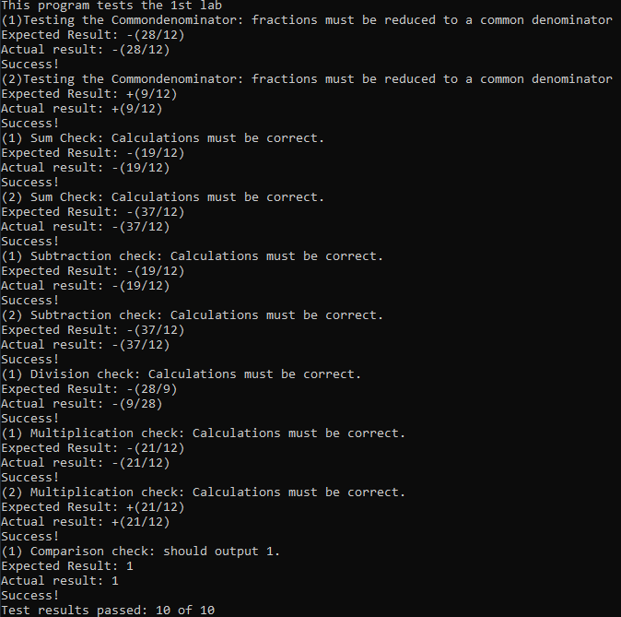

Вывод: Я освоил работу с классами. Понял механизм работы с классами, модификаторами доступа. Провел юнит-тесты и сделал их вывод.

